Bangladesh University of Professionals



Faculty of Science and Technology
Department of Information & Communication Technology (ICT)

Course Title: Industrial Training

Course Code: ICE-3211

Submitted by

Section – A, Batch: BICE – 2022

Name: Nasrat Jahan
ID: 2254901061
Walton ID: IA-539
Submission Date: 07.05.2026

Inserting 1 lakh contacts
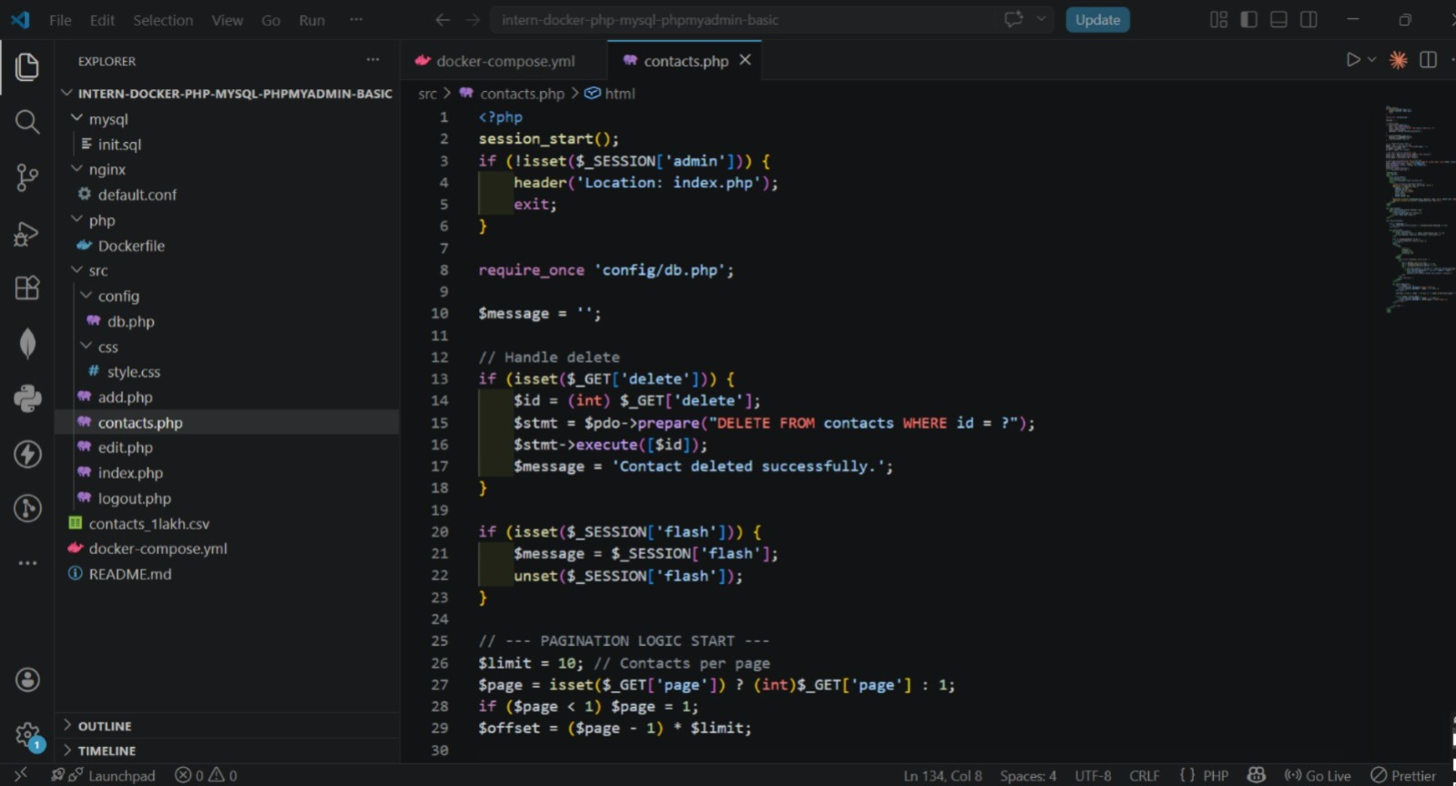
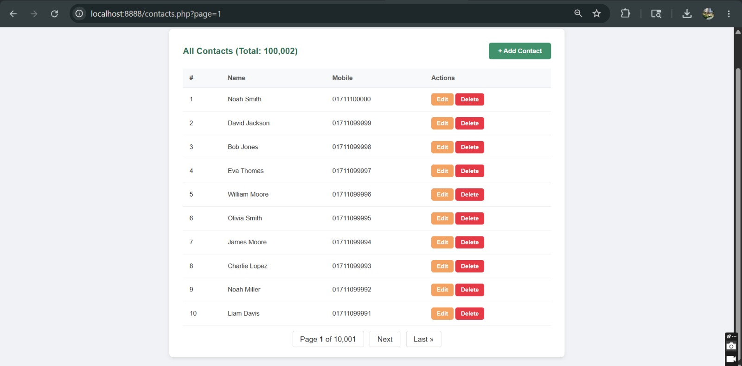
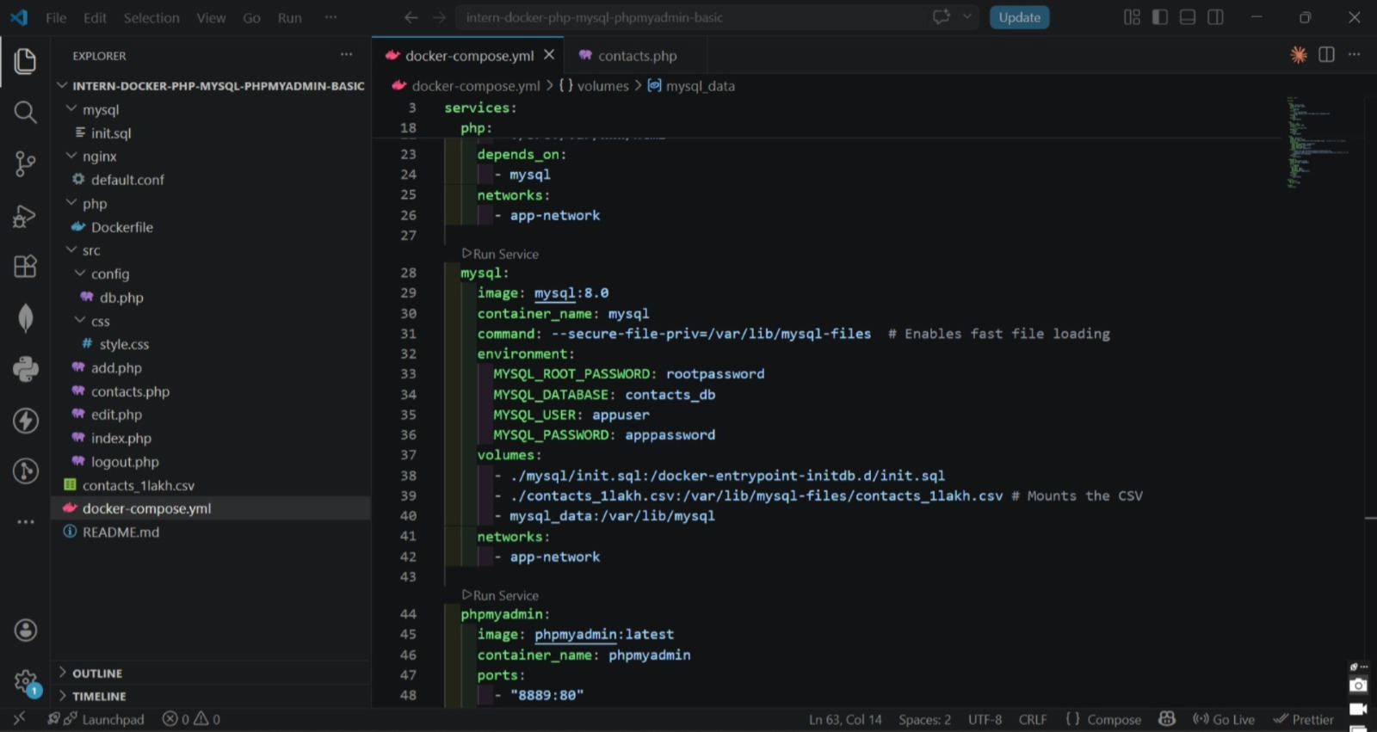

Page number
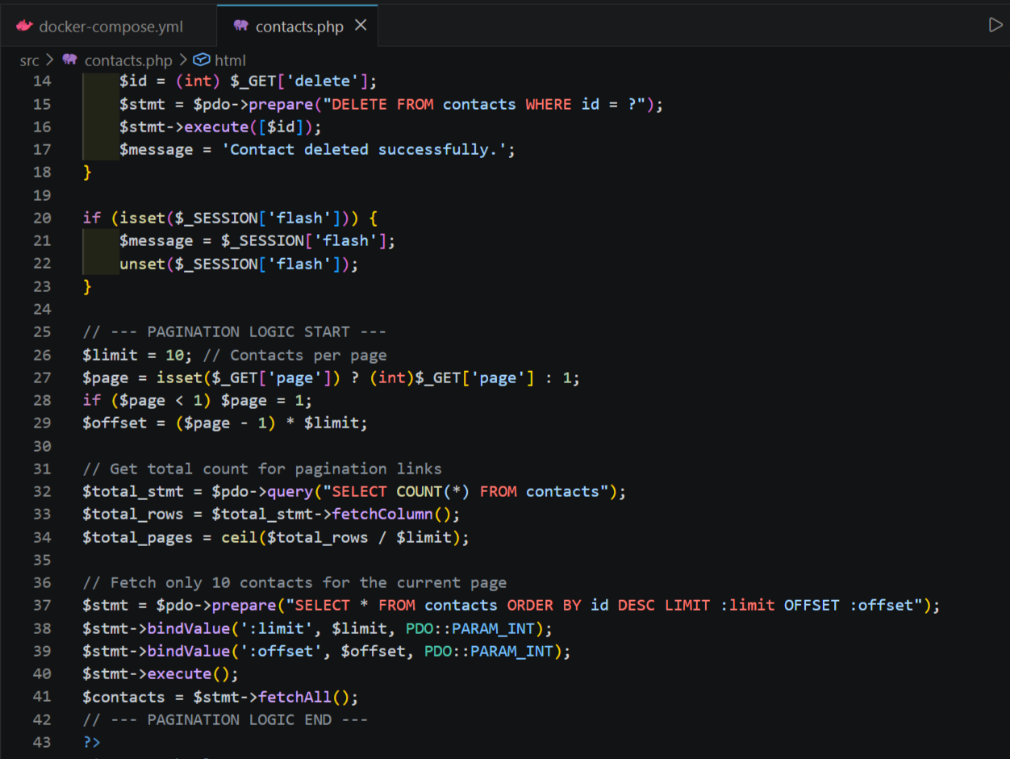

Creating Redis Container
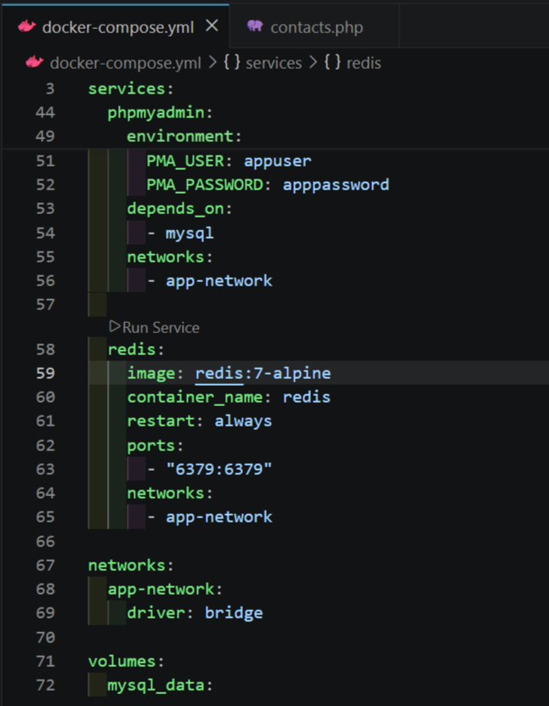
Output
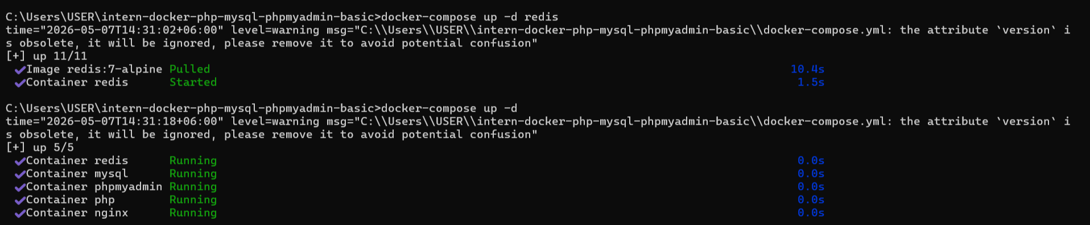
Add Redis to show Contact Information
